July 2012 Greenland Ice Sheet Thaw

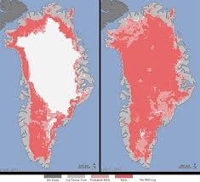
Amid the summer of 2012 drama of drought, fire, and record heat, the planet's destiny may have been revealed, in a single season, by the quiet metaphor of a silent, empty sheet of ice. In this new climate, aided by the lower reflectivity of the ice surface due to thaw and smoke particles from wild fires in the United States and Russia, the ice sheet will continue to shrink rapidly. In the new climate, the ice sheet is going to continue to shrink. The July 2012 experience would indicate the melting will take place much more rapidly that previously estimated. Should the entire ice sheet melt, global sea level would rise by about 24 feet. In the image above, on the left is the ice sheet on July 8th, 2012. The right-hand image was recorded by satellite only 4 days later.

