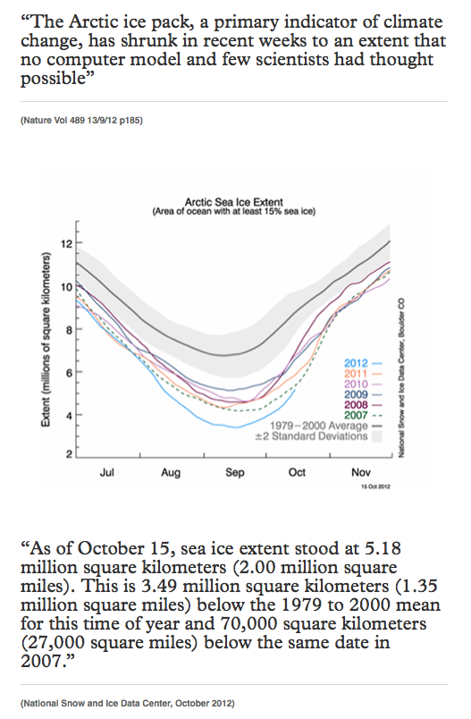
Captured from the Carbon Trust Web Site 11/14/13

